Test Case 3

**Section**: Change Password

**Precondition:**

Open cite <https://rozetka.com.ua/ua/cabinet/personal-information/>

**Step 1:**

Press the line Change Password

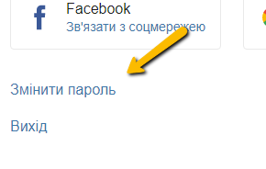

**Expected Result :**

In the middle of the site must be icon Change Password

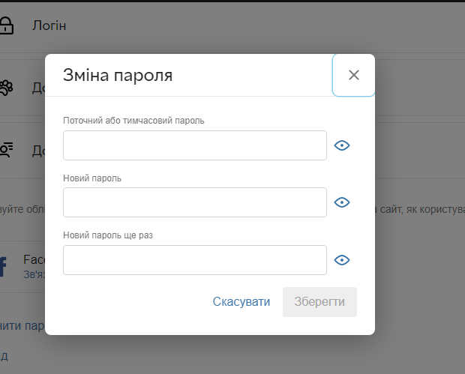

**Step 2:**

Change password to a new one and save

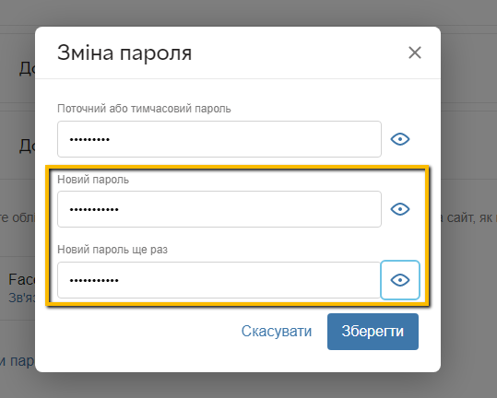

**Expected Results :**

Must be icon that Your Password has been Changed

